Name: __________________________________ Block: _______

Unit 2: The Colonists:
Immigrant Women in Upper Canada
2.5

Part A: Images: Take a look at the image below and make a list of what you see as the role of women depicted in this image from the 19th Century:

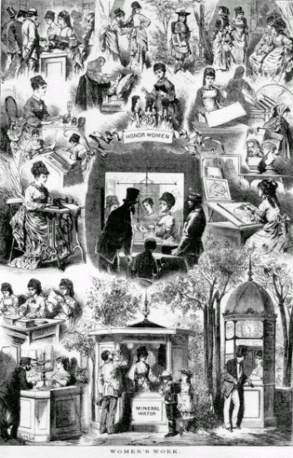
________________________________________________________________________________________________________________________________________________________________________________________________________________________________________________________________________________________________________________________________________________________________________________________________________________________________________________________________________________________________________________________________________________________________________________________________________________________________________________________________________________________________________________________________________________________________________________________________________________________________________________________________________________________________
____________________________________________________________________________________________________________________________________________________________________________________________________________________________________________________________________________________________________________________________________________________________________________________________________________________________________________________________________________________________________________________________________________________________
____________________________________________________________________________________________________________________________________________________________________________________________________________________________________________________________________________________________________________________________________

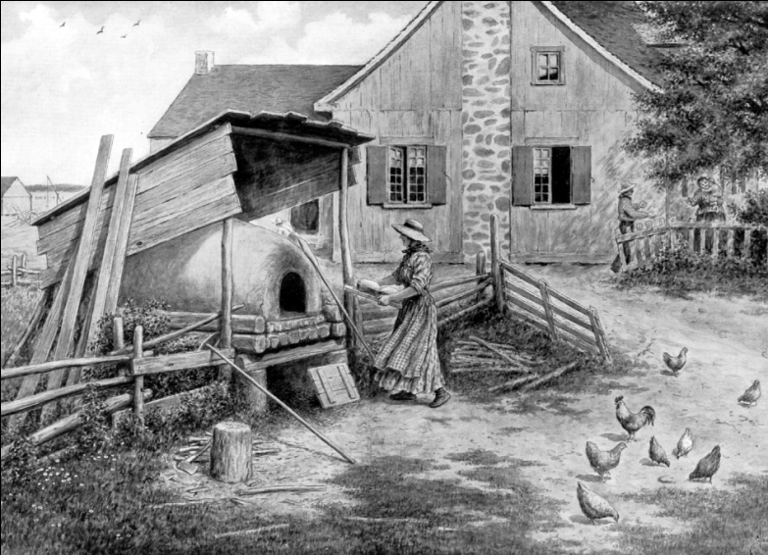
____________________________________________________________________________________________________________________________________________________________________________________________________________________________________________________________________________________________________________________________________________________________________________________________________________________________________________________________________________________________________________________________________________________________________________________________________________________________________________________________________________________________________________________________________________________________________________________

Part B: Immigrant Women in Upper Canada:

1. How did women colonists in Upper Canada define themselves? _________________
____________________________________________________________________________________________________________________________________________________________

2. Why did unmarried women and widows have to rely on their relatives for support? _____________________________________________________________________
____________________________________________________________________________________________________________________________________________________________

3. In your own words, describe how marriage was back in the 19th century? ________
____________________________________________________________________________________________________________________________________________________________

4. Why could men “marry down,” but women could not? __________________________
____________________________________________________________________________________________________________________________________________________________

5. In the chart below explain what life was like for an immigrant woman in Upper Canada. Put the duty, chore or expectation in the first column and how that would affect the woman in column two.

Chore/ Job/ Expectation | Affect on Women

