Name: ___________________________________ Block: __________

Unit 2: The Colonists: Upper Canada
2.2
Part A: Introduction: For each topic from the introduction listed below explain how it was connected to life in Upper Canada.

Topic | Connection to Life in Upper Canada
Landscape

Travel

Duties of Newcomers

Loyalists

Gentry

Part B: Daily Life for the Colonists:

1. Provide two examples of how people depended on each other in Upper Canada.
a. ___________________________________________________________________________
______________________________________________________________________________
b. ___________________________________________________________________________
______________________________________________________________________________

2. a. What is a barter economy? ________________________________________________
______________________________________________________________________________

b. If you were a farmer who needed new horseshoes for your plow team of horses, how might you barter for what you need? _______________________________________
______________________________________________________________________________

3. Using the image below, describe what a village in Upper Canada might be like:

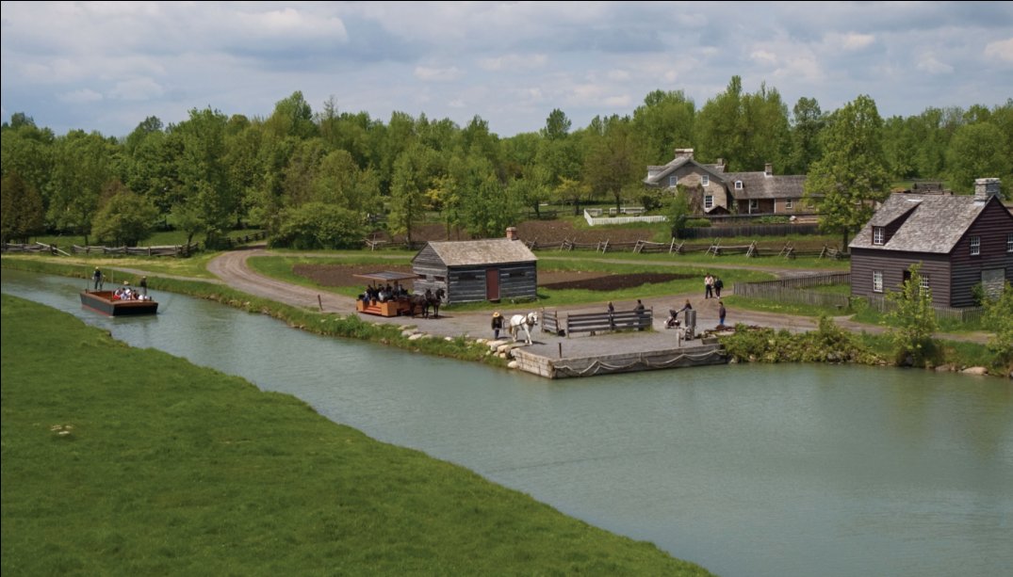

________________________________________________________________________________________________________________________________________________________________________________________________________________________________________________________________________________________________________________________

4. How was social class important to Upper Canada? ____________________________
____________________________________________________________________________________________________________________________________________________________

5. a. What are tenant farmers? ________________________________________________
______________________________________________________________________________

b. How did the British ideals of estates and tenant farmers reflect the class system from their homelands that the immigrants were escaping? _______________________
____________________________________________________________________________________________________________________________________________________________

Part C: Family Compact:

- Who were the Family Compact? ____________________________________________
______________________________________________________________________________

- What actions showed the elite view they had of themselves? ___________________
____________________________________________________________________________________________________________________________________________________________

Part D: The Problem of Land: The Land Problems in Upper Canada were the root of dissention amoungst the people. In the chart below discuss each of the following parts of the puzzle.

Land Problem | What did it entail?
Absentee Landlords

Land Speculators

Crown and Clergy Reserves

British Government

First Nations

How would you feel about this issue, if you live in Upper Canada during this time period? ____________________________________________________________
____________________________________________________________________________________________________________________________________

