Media Arts 11
Using Windows Movie Live Maker – An Introduction
Steps:
*I recommend you begin your project by gathering all of the photographs, video clips, audio clips (ie. Music, songs, etc.), into one single file so you don’t lose any of your important work! If you’re really on top of things, you could make subfolders for each genre SAVE YOUR WORK AS YOU GO!
- Open Windows Live Movie Maker on your laptop
- Once the program is open, you will see this screen: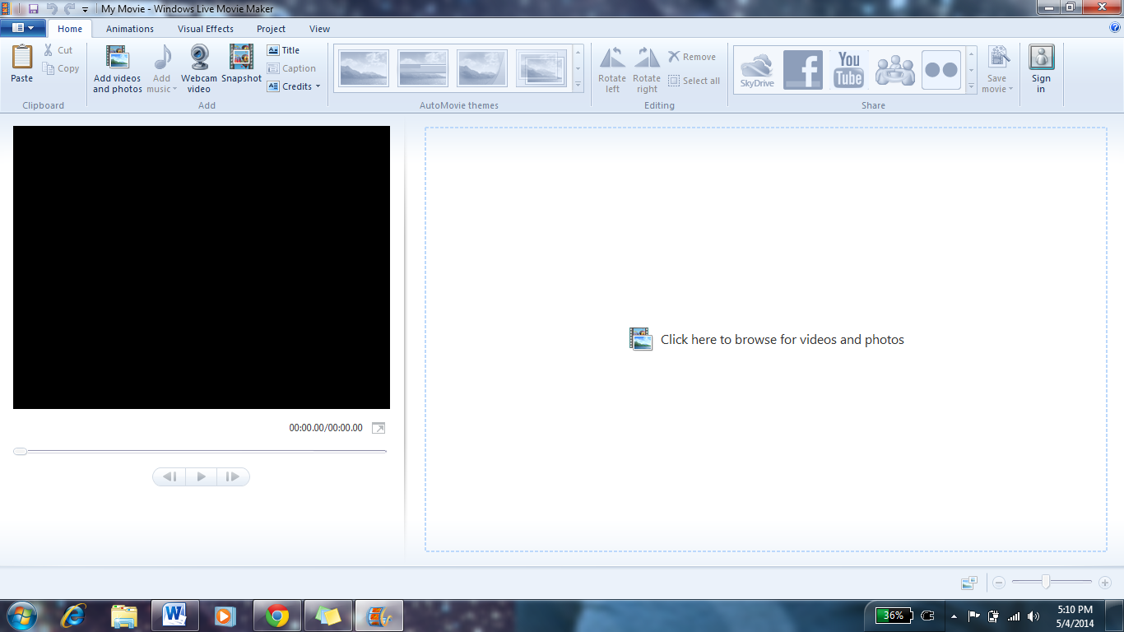
At the top left corner you will see these options:
- To insert videos or photographs you will select the “Add videos and photos” button under the “Home” subfolder. Add the video clips you would like to work with first. You can add more videos at any point and time and can move them around as you please.
- Once you have inserted your selected video(s) (or photographs) you now have the option to “trim” the video clips to the length you would like each one to last.
- To edit your video clips, click on “Edit” under the new “Video Tools” menu.
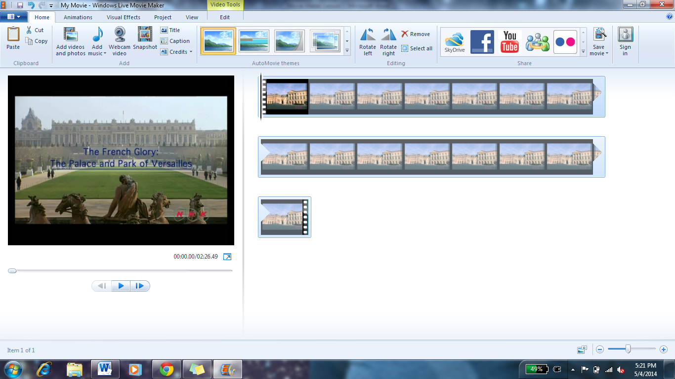
- You can shorten the video clip by clicking on the “Trim tool” button. You can adjust both the start and end time of the video clip.
- Once you have clicked on the “Trim tool” you will come to a new set of options which will allow you to choose your specific start and end time. You can do it this way, or you can drag the bar on the video. Once you have altered the clip to the length you want it to be, click “Save time” or if you are unhappy with what you’ve done you can click “Cancel” to go back.
- You can rearrange the order of your video clips to have them in the order that you would like them to be in (if you don’t like where you put them the first time).
- Your video will have audio, whether it is from your original video clip or from audio that you choose to add.
If your original video clip has audio that you would like to take out so you can put new music in, you can change the Video volume or have it fade in/out to other audio.
To add new music, go back to the “Home” menu and click on “Add music”
This screen will appear. Choose the audio that you would like to add.
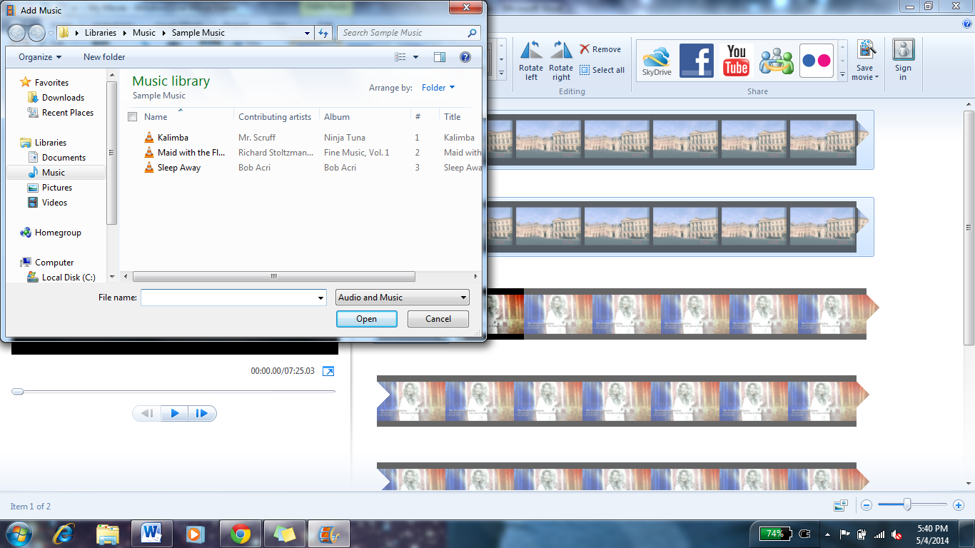
10. Once you have added your chosen audio, you can now alter the length, start/end time of the audio, and fade in/out of the audio.

11. To edit your audio, click on “Options” under the Music Tools menu.
12. In this new menu you can alter your audio however you would like to. As seen in the image below, Movie Maker has made it very simple for you!
13. You have the option to put animations (special effects transitions) into your video as well. This is a neat effect if you are doing a slideshow presentation or are moving between photographs. To do this, click on “Animations” at the top bar.
Once you click on this button you have a variety of options. Each option will create a different effect between image transitions (not audio, images only!)
14. You can add different text effects to your videos. Go to the “Home” menu and you will see 3 options: “Title”, “Caption”, “Credits”

15. “Title” creates a title screen like this:
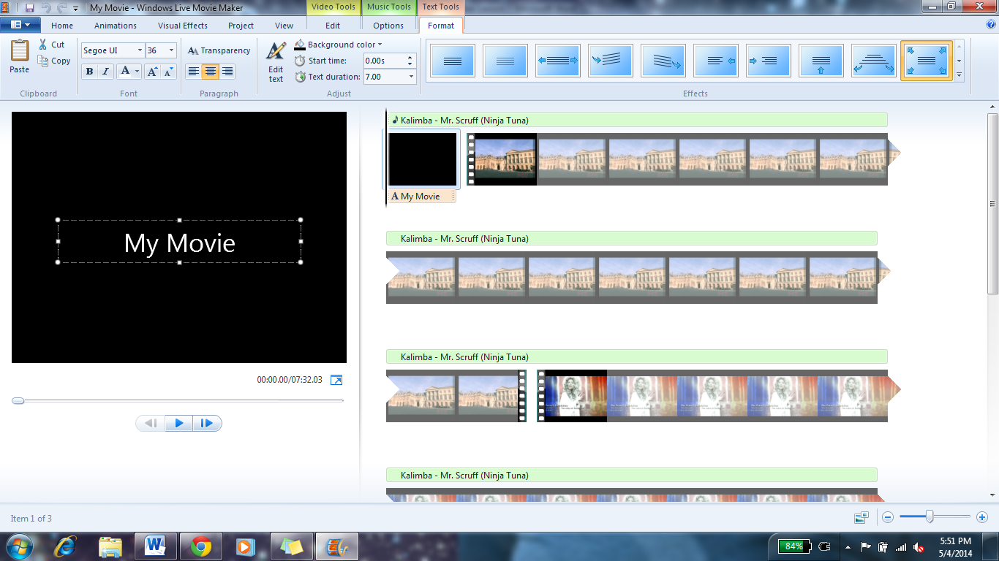
There are different options for your title screen
You can edit the orientation of the words, the text you write, the background, etc.
These buttons on the right will let you create different transition effects for how your text will present itself… try them out, they’re pretty cool

16. To add a caption, click the “Caption” option. Once you have done this you will be taken to a screen that looks the same as the title, but you can drag your text to any place in your video. The text will show up on top of the video/photo!
This is where I dragged the caption (I grabbed it from the first slide and pulled it over)
…This is where it shows up over the video when it plays!
This is where I dragged it….

17. To add credits at the end of your video (like in the movies!) click “Credits” and the screen will look like this:
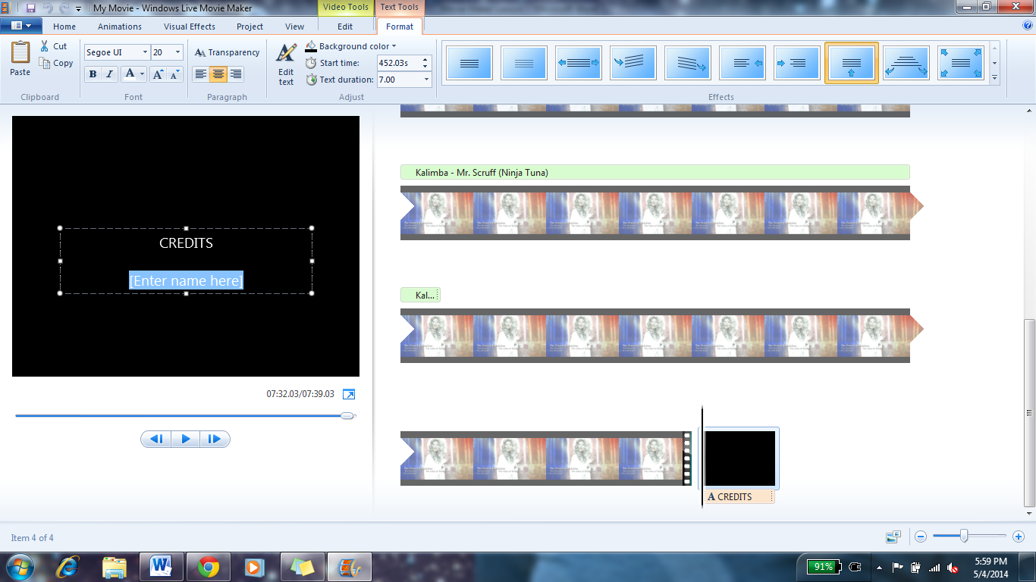
Type in the information that you would like to input. You can alter the text, size, effects, etc.

DON’T FORGET TO SAVE YOUR VIDEO AS YOU GO!

