Image Inside Text
Photoshop Tutorial

Step 1: Open the photo file you want to use
For this tutorial, we used a beach scene. You want your photo subject to be distant for this project.
Step 2: Name the layer & add text
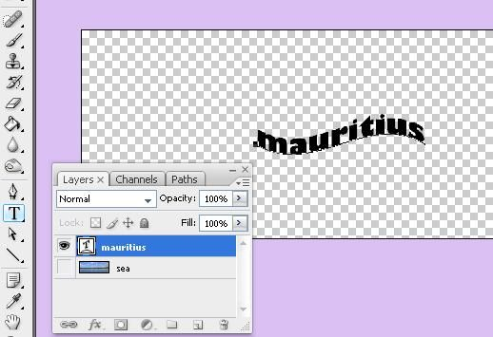
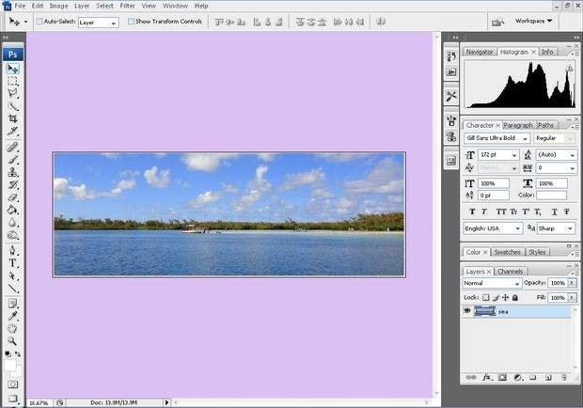
In order to put an image inside text. It requires a clipping mask, which is easy to make

Step 2: Change the Font & scale the text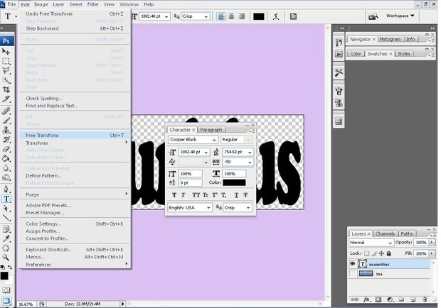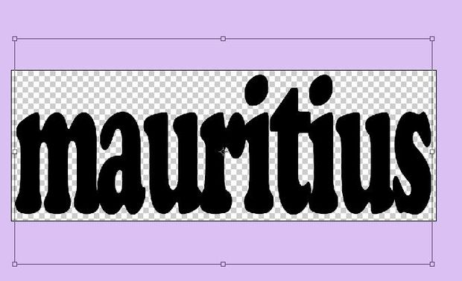 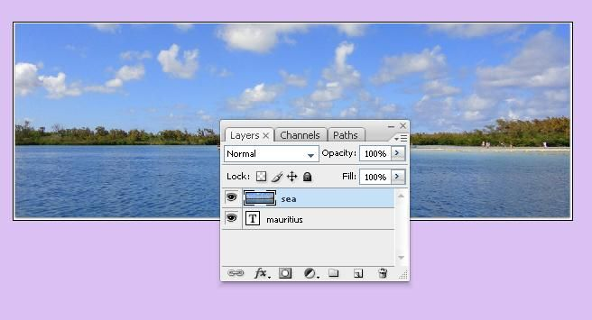

- change the font and size accordingly ;
- ctrl + T to free form the text > resize it
- move the image layer on top .

Step 3: Clipping Mask
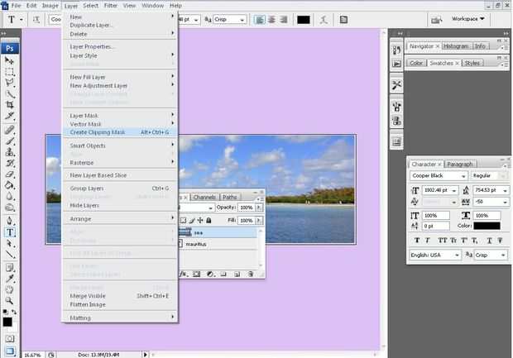
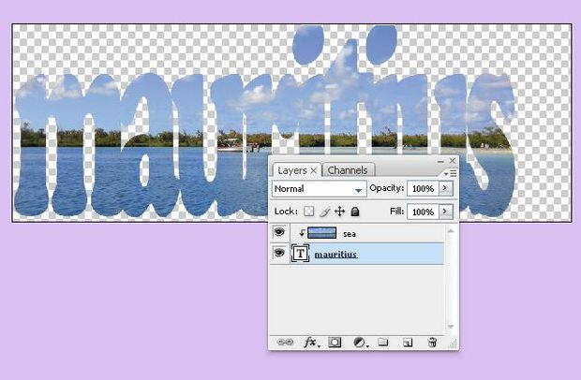
- With the image layer selected in the Layers panel, select the Move tool from the Tools panel. Click on the image and move it around until I like how it's positioned inside the text.
- You can now choose File > Save and call it done, or continue on to add some finishing touches.
Step 4: Outline the Text
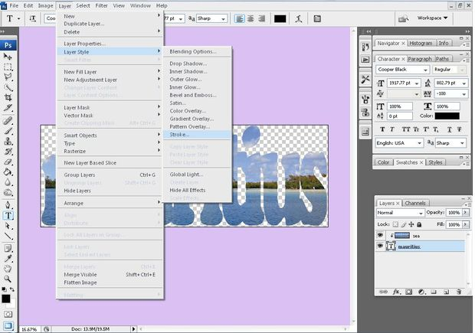
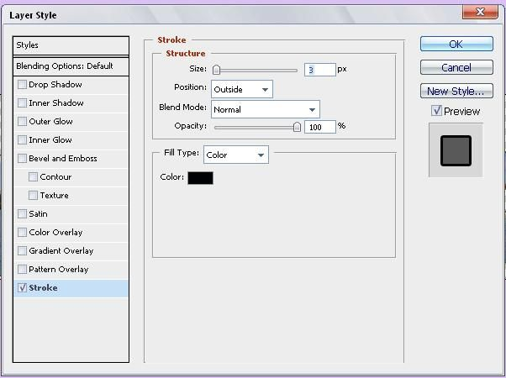
- open the Layer Style window by choosing Layer > Layer Style > Stroke.
- Know that there are other ways to open the Layer Style window.
- You can double click the text layer, or with the text layer selected
- click the layer style icon at the bottom of the Layers Panel and choose Stroke

Step 5: Select a Stroke Color
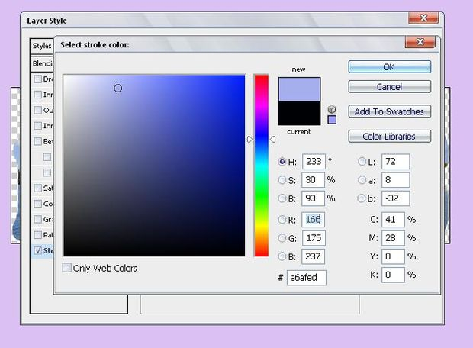
click on the color slider, or move the color slider triangle up or down until u like what u see in the Color field. I'll move the circular marker within the Color field and click to select a stroke color. I'll click OK, and click OK again.

Step 6: Create a New Layer
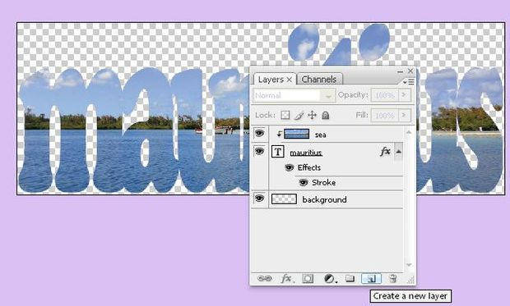
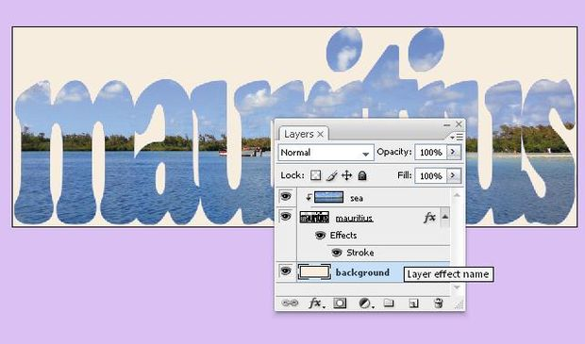
In the Layers panel, click on the Create New Layer icon. click and drag the new layer down under the other layers, double-click the layer name to highlight it, then type in the name, "background."
Step 7: Final work
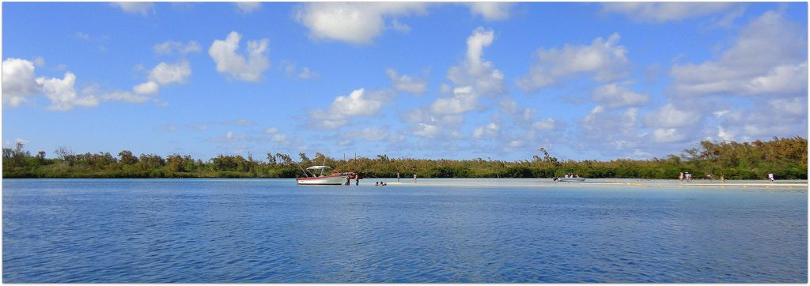
**the original picture and the modified text image

