How to Change Eye Colour in Photoshop
Photoshop Tutorial

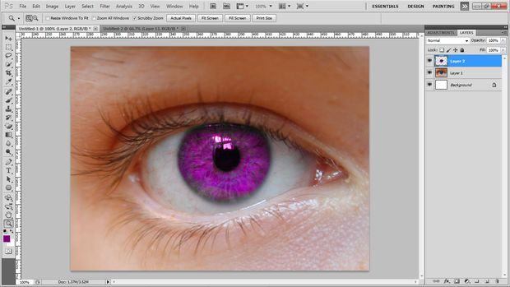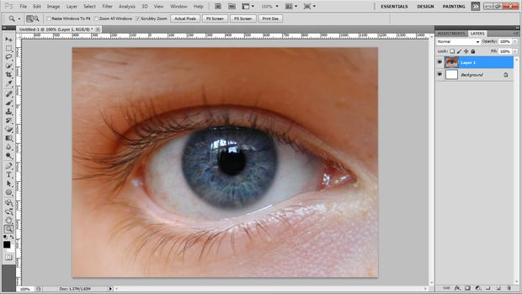
Step 1: Pick a Starting Photo
You’re going to want a large, high-quality photo. I find that blue or green work the best. Try to find one that has a lot of detail in the iris. I used the one below.
Step 2: Selecting the eye
- Use the pen too to outline the eye.
- Then right-click and select "Choose Selection".
- Click ok.
- This will surround the eye with the spinning marquee.
- Next click ctrl-J Or cmd-J on mac; this will Duplicate the eye.
- Now click Ctrl/Cmd – D
- This will deselect the marquee.
(See photos on next page)
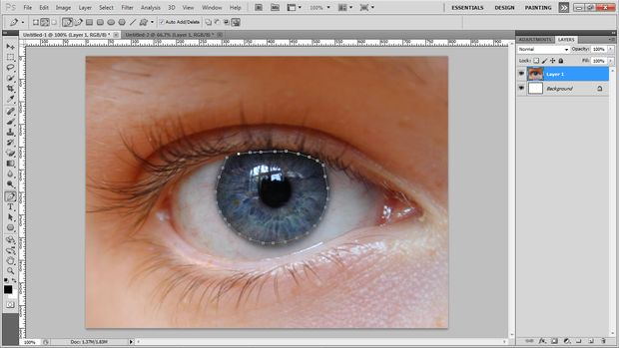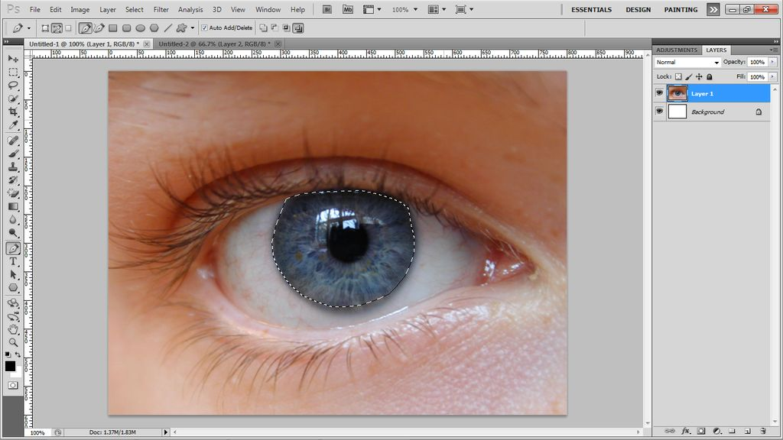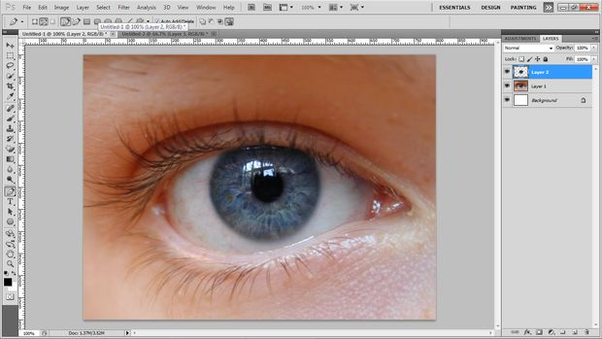
Step 3: Changing the Colour
- Now, Click layer > New Adjustment Layer > Hue/Saturation.
- Now the on pop-up, click ok. This will change the side tab.
- Slide the color slider till the eye itself is the color you want. The rest of the image will change color too, but don't worry. We will fix that in a minute.
- Now, if the color is not and "Colorful" as you want, change the saturation up. This will add more color.
- Now, too save the color to just the eye, click ctrl/cmd - E
- This will merge the adjustment layer and the eye layer. When you merge them, the color should only be applied to the eye.
See photos on next two pages
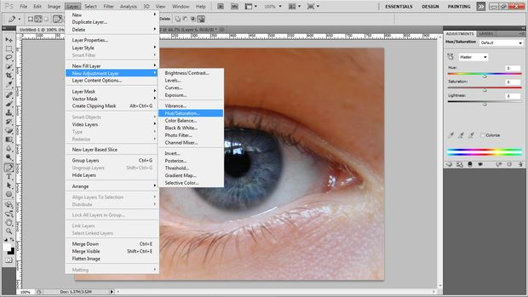
Step 3: Changing the colour, continued….
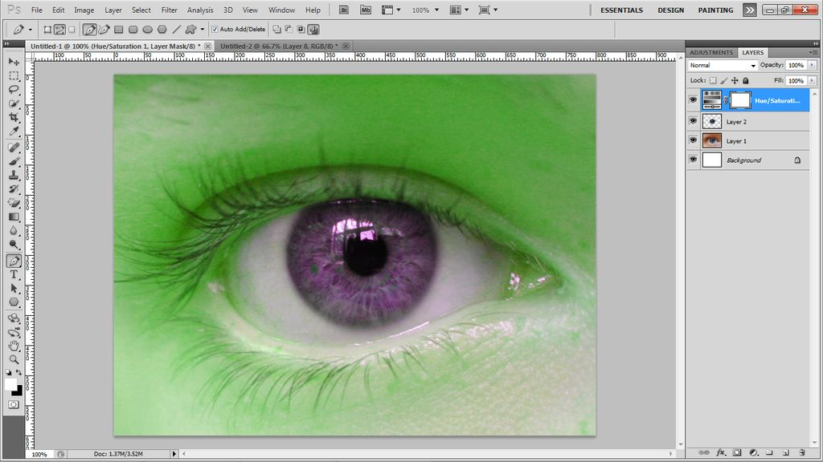
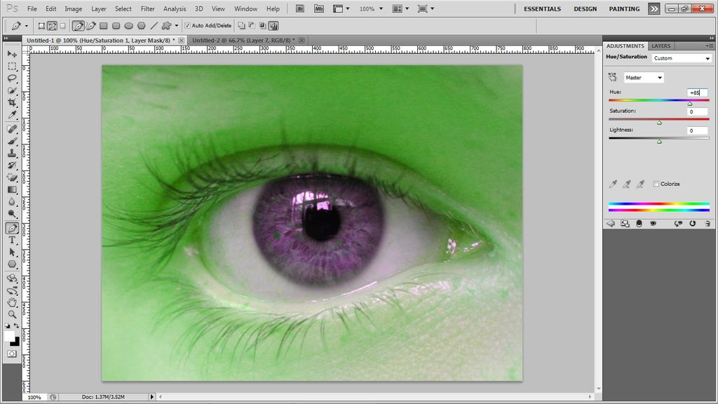

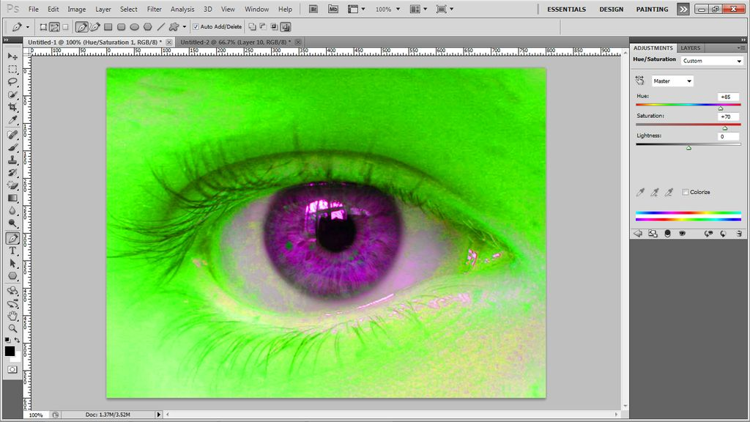
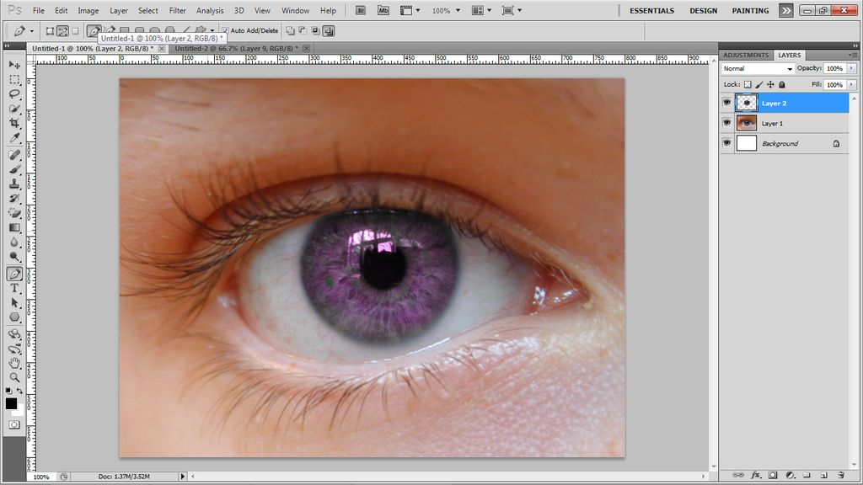
Step 3, continued…
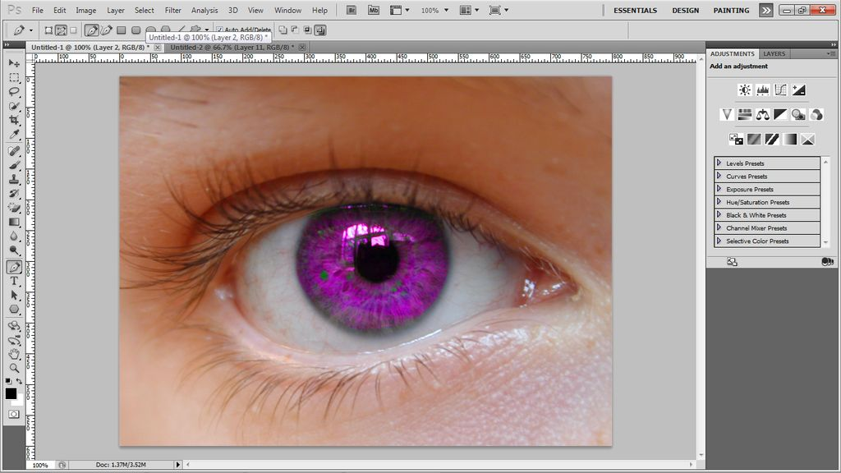

Step 4: Final touches
Now, if there was any artifacts, or unwanted marks, you can use the the clone tool. You should end up with something like below

