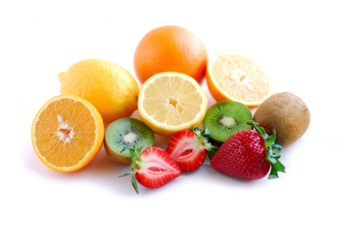
Health and Career 9
Name: _________________________________
Healthy Living – Eating Habits Assignment

You may know that your health is significantly affected by what you eat. One of the key characteristics of a physically healthy person is a balanced healthy diet.

Part 1: Think about your own habits
Analyze your own diet. In the following chart provide examples of what you might eat on a regular day.
Breakfast | Lunch | Dinner | Snacks

Part 2: Reflect and assess
Look at the list you just made. Circle the foods that you would consider “healthy” or “nutritious”; underline the foods you would say are “unhealthy”

Part 3: Healthy Eating Continuum
Healthy eating is directly linked to academic performance. On the continuum below:
(1) describe how healthy living is linked to academic performance
(2) describe how academic knowledge could help you eat healthier

Part 4: Building on what you know
Last week we learned about characteristics of physical and emotional healthy. Describe ways that healthy eating habits support physical and emotional health using the following examples.

1. fuels the body for activity

2. helps a body grow and develop

3. helps prevent disease

4. improves the ability to concentrate

5. increases energy

