Create A Colour Accented Photo
Photoshop Tutorial

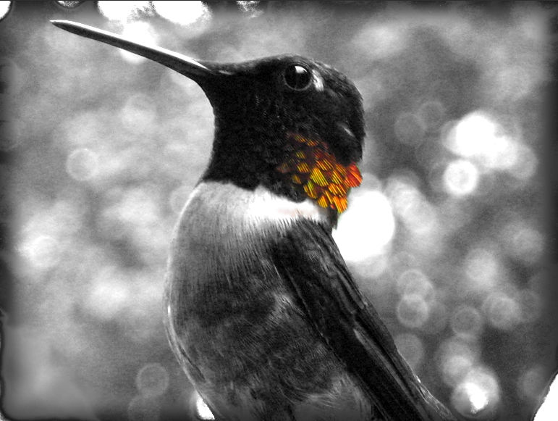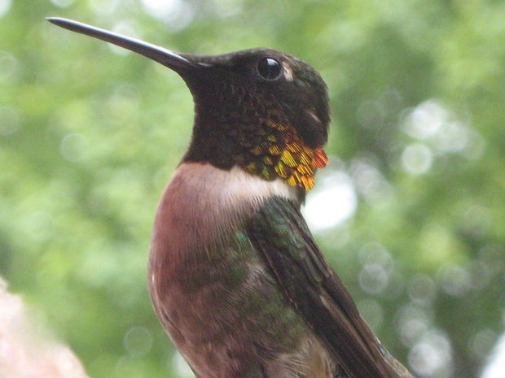

Step 1: What you will need
You will need the following things to do this:
- Photoshop
- A color photo to accent

Step 2: Prep work

Open up the picture you want in Photoshop. Create a new layer from the image. Remove any blemishes or anything else that you don't want in the new layer

(See screen shot photos on next page)

Prep work, continued…
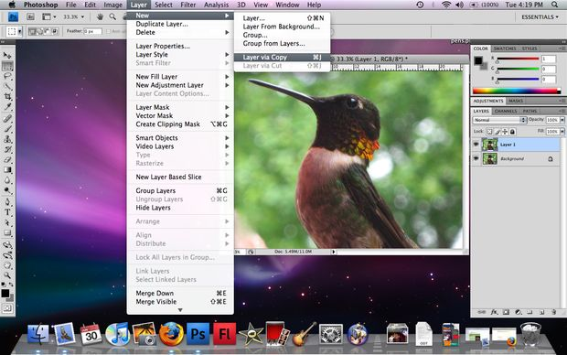
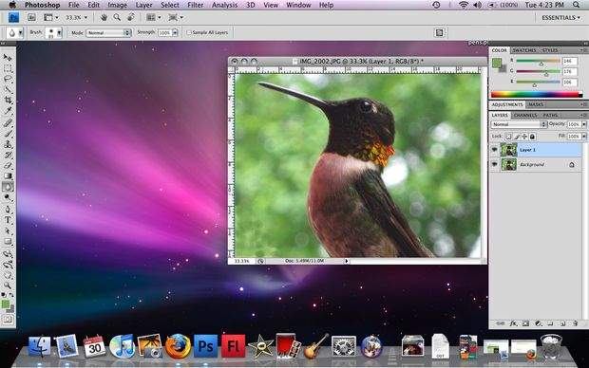
Step 3: Old School! (notes on next page)
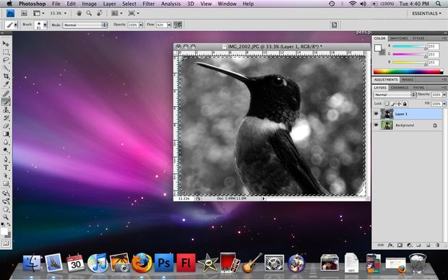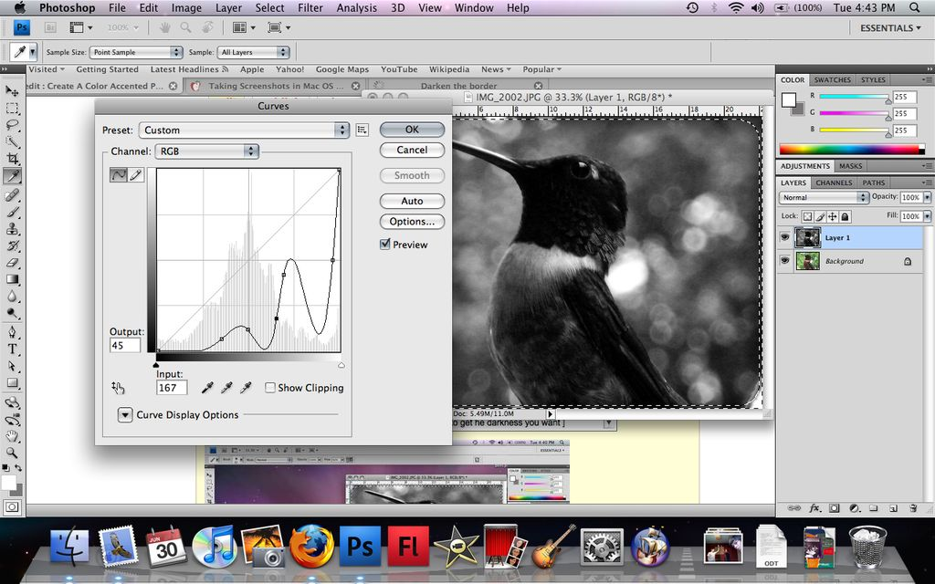

Step 3 Continued: You are now going to turn your new layer into black and white, there are two ways of going about doing this
1.) Image > Mode > Grayscale
~OR~
2.) Image > Adjustments > Hue / Saturation [ Set saturation to -100 ]

THEN
Image > Adjustments > Levels [click "select black point" and then select a black spot on the picture and click it
These steps are shown on the first picture on the previous page

THEN
Image > Adjustments > Levels { click "select white point" and select a white point on the picture and click it

THEN
Select > All and then Select > Modify > Border

THEN
Select > Modify > Feather

This step is shown in the second picture
THEN
Image > Adjustment > Curves [ Play around with the curve to get the darkness you want ]

YOU ARE NOW DONE WITH THE BLACK AND WHITE PART

Step 4: erasing

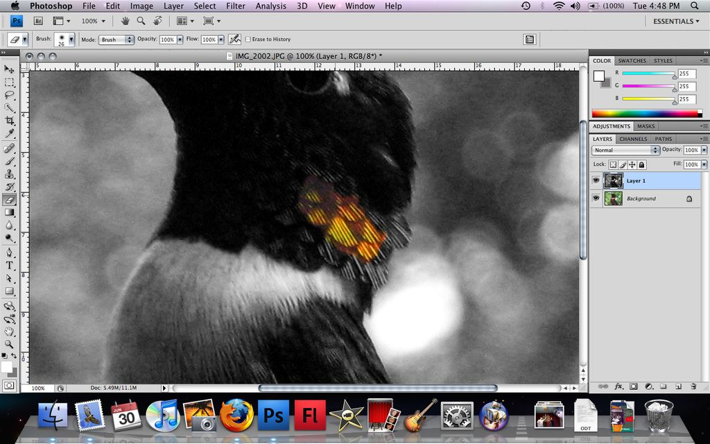
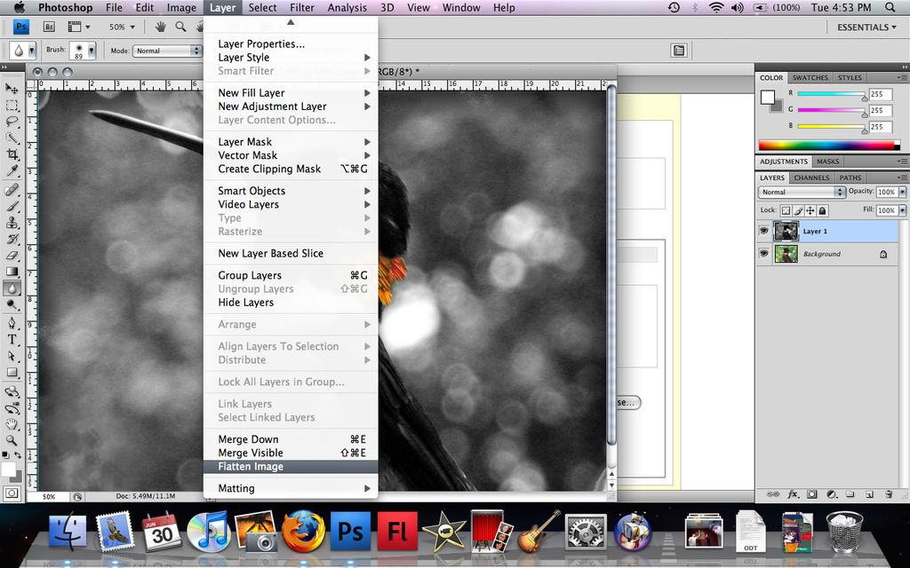
Step 4: Erasing, continued

Now is when your graphics tablet comes in handy. Click on the eraser tool and slowly erase the black and white layer in the place where you want the color to be. You can keep track of your progress by occasionally turning off the B&W layer to see how close you are to the edges. When you are finished, go to Layer > Flatten Image

Step 5: Done!
