Name: _________________________________ Block: ____

Unit 2: The Colonists
Looking Back to the Start of the 19th Century
2.1
Part A: The Land of Yesterday: As you view the slide show on what Early 19th century British North American was like, jot down facts from the presentation below in column one. In column two, why do you think this point is important for you to know.

Fact | Why it is Important

Part B: First Nations: The start of the chapter touches on “Those Already There.” Use these questions to focus your inquiry.

- Create a mind map in the space below that shows problems the first nations people’s faced in the early 19th Century.

First Nations

- What is the Royal Proclamation of 1763 ?(the year is given because there are other Royal Proclamations in history, but this one is especially important)
__________________________________________________________________________________________________________________________________________________________________________________________

- What are some of the misconceptions about the First Nations from the early 19th Century? Why did the misconceptions occur?
________________________________________________________________________________________________________________________________________________________________________________________________________________________________________________________

Part C: Whose land is it? The settlers had their own understanding of the division of Canada. Use the questions in this section to guide a partner talk.

- Can you decipher what belonged to whom? On the map below illustrate your understanding:
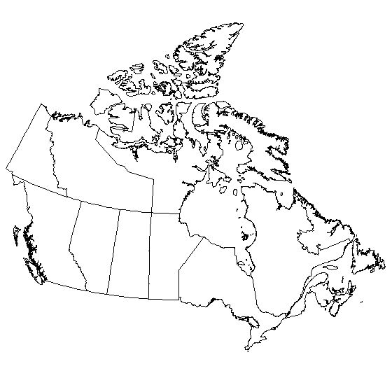

2. Why does it appear that so much of Canada was for the fur trade, not for the colonists? ________________________________________________________
________________________________________________________________________________________________________________________________

3. What did the colonists want to help this imbalance? _____________________
________________________________________________________________________________________________________________________________

- From the Fur trade prospective what was the problem with what the colonists wanted? _______________________________________________________
____________________________________________________________________________________________________________________________

